
Computer Sciences Corporation

Report on
Systems Management Server
for



Western Australia Police Service

SMS Terminology

Discovery: The process where a resource is known by the SMS database.

Client system: A computer system that has the client Software installed.

Site Code: A three-letter code used to identify each SMS Site.

Logon Point: Acts as the logon point for SMS Clients (must be a Domain Controller).

CAP (Client Access Point):
- Processes SMS Logon
- Acts as a communications hub between clients and the Site Server.

Central Site Server: The Primary Site Server at the top of the SMS Hierarchy.

Site System: Any server providing services to SMS.

Site Server: A server that is performing the Site System role.

Primary Site Server: A Site Server that has its own database.

Secondary Site Server: A Site Server that sends data to a Primary Site Server’s database.

Executive Summary

The following is a list of known problems with SMS in its current implementation. This document may only be used as a guide, and is not intended to replace any existing documentation.

SMS in the WAPS environment is severely limited in almost every core function.

The status of each SMS function is listed in the table below:

Function | Status | Reason
Resource Discovery | Incomplete | WAN Congestion, Server Placement, PC’s asleep
Helpdesk Tools (Remote Control) | Downgraded | WAN Congestion
Software Distribution | Downgraded | WAN Congestion, Server Placement
Hardware and Software Inventory | Downgraded | WAN Congestion, Server Placement
Software License Metering | Not utilized | Not in original design
SMS Reporting | Not utilized | Software not provided, Insufficient Hardware
Network Analysis | OK

Resource Discovery

Resource Discovery is primarily being hampered by the WAN links between the potential client, and its parent site system. Because of the congestion on these links, potential clients cannot be discovered, and subsequently not appended to the SMS Database. In addition, any SMS Discovery Method cannot discover a PC that is ‘asleep’ due to Power Management.
There are currently 824 SMS Clients out of a total of 512 discovered systems. These figures are incorrect, because of a problem with the way SMS reports client systems. This is still only a subset of the total of 3751 known systems in WAPS at the time of writing this document.

Remote Tools

Helpdesk functionality is only available to systems with the SMS Client software installed. There are currently 824 clients in the SMS database.
Performance of Remote tools is dependent upon WAN utilization, and will itself degrade the WAN between the client and its partner by a certain amount. Remote Tools have been found to be unusable across normal Satellite links, but are initial testing has indicated that it may be OK over the new Enterprise Relay links.
The following two pictures show the results of a SMS ping and a remote control session to a PC in Wongan Hills. This is a small site, and the results of this test are inconclusive, but encouraging.

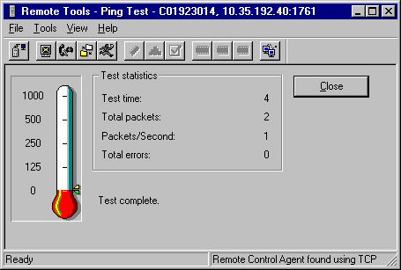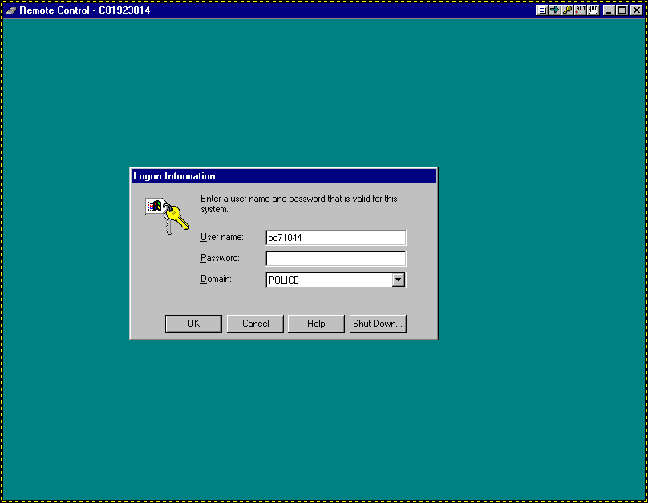

Hardware and Software Inventory

Hardware and Software Inventory is only available on systems with the SMS Client installed. This inventory is updated periodically, and will cause a small amount of WAN traffic to that Link. This is a delta update, and is expected to be minimal (after the initial complete scan).

Software License Metering

Software License Metering was briefly mentioned in the original SMS design specification, but is not configured for the WAPS installation. The use of the Software License metering function is out of the scope of this document. A discussion of Software License Metering would include information such as:
- Increased WAN and LAN Traffic
- Increased workstation load
- Recommendations for additional hardware
- Recommendations for upgrading of current Central Site
- Limitation on use (i.e. the small remote sites would not be targeted without an additional Site Server to be located at each Very Small Site.

SMS Reporting

SMS Reporting is possible in a basic manner, but detailed reporting tools (Crystal Reports) have not been provided to facilitate this function. The requirement for these tools was detailed in the original design document.
To use the inbuilt SMS Reporting features, an additional server with it’s own SQL Database would need to be provided. This server would have no SMS Clients attached to it, but would provide reporting capabilities only.

Network Analysis

Network Analysis is a reporting tool that maps a Network Diagram, with results based upon the contents of the SMS Database. This feature is functional, but very slow due to the speed of the Primary SMS Server.

Software Distribution
Software distribution is also dependant upon WAN utilization, but is primarily affected by the location of the client’s parent site server in relation to itself. The following diagram illustrates the basics of the Software Distribution process in a WAN context.

Each diagram shows how a single SMS package will travel from the Central Site, to the Distribution Server, and on to four client systems.

Diagram 1 illustrates how a single package sent to four clients will travel once across the WAN Link, and is the correct installation method

Diagram 2 shows the method used in the WAPS SMS design for most remote sites, and illustrates how one SMS package will travel across the WAN Link four times, thus saturating this particular WAN link.

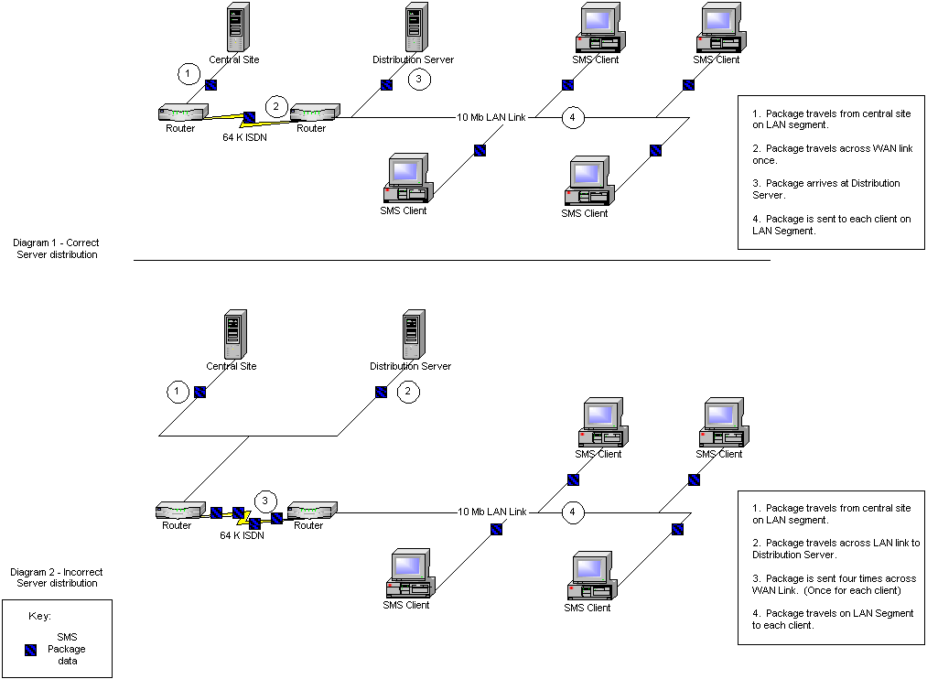

Current Issues

Problem: VSM Site-code clients

Most systems at the Very SMall site cannot be targeted for ANY SMS feature, or if targeted, results returned have proven to be unreliable.

This was not unknown to the original designers of the SMS Installation, and was brought to the WAPS attention a number of times (e.g. Email M Lentz/G Fee 27-08-99, Email M Lentz/G Fee 20-09-99).

Recommendations:
Choice of three options-
- Discount all systems in these sites for SMS operations
- Provide additional software from third parties to address these issues (NOT the preferred option)
- Provide a site server at each site to correct the implemented design

Diagram 3 illustrates various installations across subnets.

Diagram 3 – SMS Installation on various types of subnet
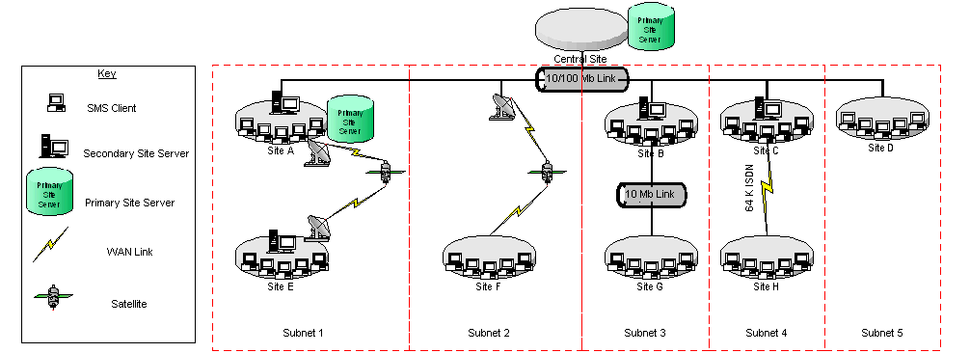

Subnets 1, 3 and 5 are correctly configured.
Subnets 2 and 4 are not correct, and problems will exist in installations similar to this.

Subnet 2 is the proposed WAPS design for most VSM sub-sites.

Basic SMS Design principles state that unless a “fast reliable connection” exists between subnets, then a SMS site should not span subnets. Microsoft defines a “fast connection” as being 2Mb/sec or better.

References:
- “A site should never span a low-speed or unreliable network connection.” – MS SMS Training (ISBN 1-57231-834-1) pp 377
- “Not installing a site server on a remote network requires fewer hardware resources, but using this structure should only be considered if there is a fast, reliable connection between the local site and the remote site” – MS SMS Training (ISBN 1-57231-834-1) pp 378
- “A site design in a WAN using one site server will significantly increase network utilization across the WAN connection during inventory collection, online software metering, and software distribution” – MS SMS Training (ISBN 1-57231-834-1) pp 383
- “As a general rule, link speeds under 2 megabits per second (Mbps) are considered slow links” – MS SMS Training (ISBN 1-57231-834-1) pp 384

Additional third part software exists that can assist with software distribution over WAN links, but this is expensive, and very difficult to synchronize with SMS. (E.g. suresnyc - $2800)

WAN utilization on these sites may also be controlled by additional third party software. This too is expensive. (E.g. floodgate1 - $17000)

Problem: Satellite Communications links

Sites with Satellite Communications as the primary communications method are expected to have major issues with all SMS functions.. Recent tests have shown this to be the case, with the possible exception of Remote Tools. As with most SMS functionality, if 40K of bandwidth is not available, the function will fail. This applies mostly to the install of SMS Clients and the distribution of software. This was brought to the attention of the WAPS a number of times (e.g. WAPS Network Infrastructure Upgrade - SMS Design Issues Meeting held on 19-08-99, WAPS SMS Design Document 17-08-99, WAPS SMS Design Document 04-10-99, Addendum to WAPS SMS Design Document 04-10-99).

Recommendation – Do not use Satellite links to communicate across SMS sites.

Problem: Clients not being installed (all sites)

Systems at multiple sites are not being installed. This is due to;
- WAN utilization,
- Placement of Domain Controllers,
- Over Utilization of Central Site Server,
- SMS bugs (Covered in the section ‘SMS 2.0 SP1 Design Limitations’)

Recommendations –
- Install site servers at each SMS Site,
- Increase the number of Domain Controllers in the WAPS Domain,
- Upgrade Central Site Server, and
- Provide additional server for SQL

Consequences of not adhering to these basic design criteria include
- Software distribution unreliable,
- Hardware and software inventory unreliable,
- Asset Management unreliable,
- Remote control dependant upon WAN Utilization,
- Dramatically increased WAN utilization,
- Software license metering – not feasible without additional hardware and bandwidth

Problem: Central Site Server Over Utilization

The SMS Central Site Server in its current configuration is working to capacity to perform the tasks required of it.

Due to the implemented SMS design (i.e. not the original design), and resultant processor usage on the only Primary Site Server resulting from this design, the Central Site Server is unable to perform all tasks within an expedient timeframe. To remove some of the load from this server, it would be acceptable to place the SQL Server database on a different server. An upgraded CBDXAAF is the logical choice for this task, but only if the VSM sites were removed from the SMS Design. Any design change should not be looked upon lightly.

Following is a diagram that shows the CPU usage of CBDXAEE. As can been seen from the graphs, both CPU’s are constantly working very hard. This has the effect of causing SMS tasks to ‘lag’, in that they can take an overly long time to complete, or depending on the size of the task asked of it, never complete.

To temporarily alleviate the load on this server, an additional 512Mb of RAM and a third processor have been installed. This has had the effect of allowing the server’s processor utilization to drop to around 80% continuous and is in itself not a solution. The addition of the extra RAM has however proven to be very beneficial, 1 Gb should be regarded as the minimum for this server.

As a comparison, most other servers in use, including the main server in HQ (CBDXAAA) usually have an average of no greater than 20%, with occasional peaks to ~80%.

Diagram 4 – CPU Usage of Central Site Server
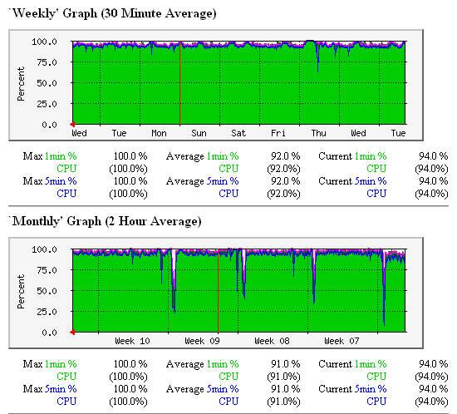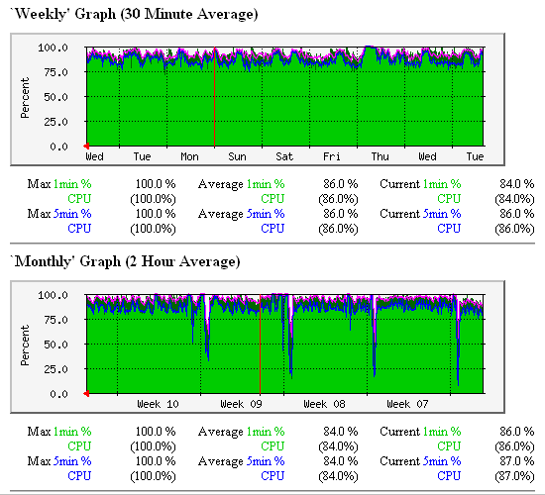

Recommendation – Upgrade Hardware on Central Site Server, and move SMS Database to separate server

The upgrade of the SMS Central Site Server (CBDXAAG) is out of the scope of this document, and would be detailed in a separate document.

A fully functional SMS site would be structured similar to the following diagram:

SQL Server
SMS Server

Diagram 5 – Conceptual SMS Site

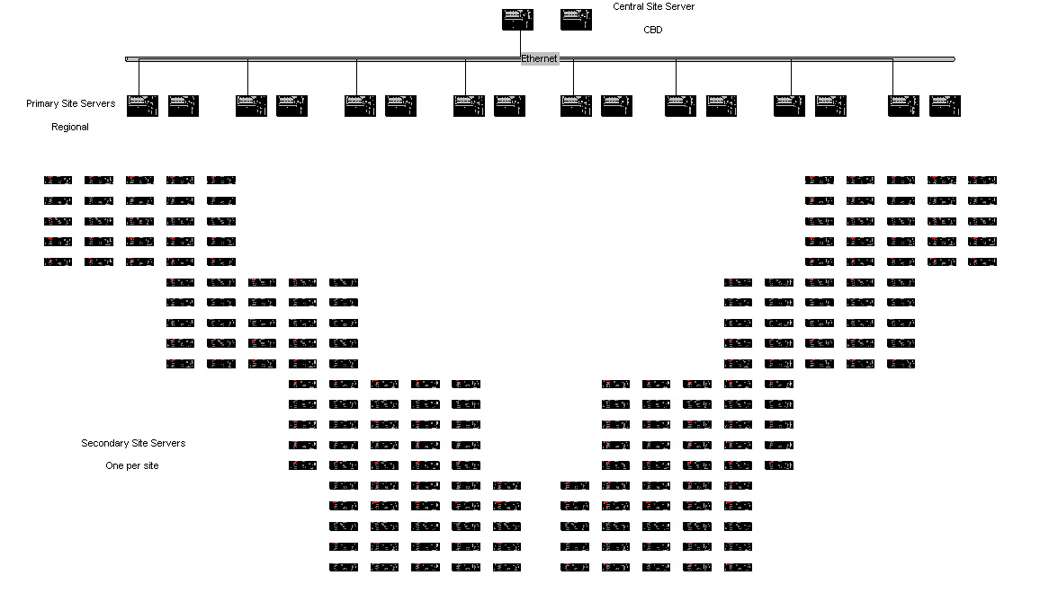

SMS 2.0 SP1 Design Limitations

Limitation to the number of Secondary Sites per Primary Site

Microsoft Systems Management Server V2.0 Service Pack 1 has a design limitation in that each primary site is limited to a maximum of 30 secondary sites. The original designers of the SMS Network did not know this because this information was not made available by MS until Feb 2000.

The current WAPS SMS installation has one Primary Site Server, and 81 Secondary Sites. This has the effect of overloading the Primary Site with status messages and tasks, and will eventually cause the SMS Primary Site Server to fail. (Ref Telecon D Robinson (CSC)/D Mulukin (Microsoft) 01-03-00). This is already evident in the evidence presented so far.

Diagram 6 illustrates the current WAPS SMS Design, and diagram 7 illustrates one SMS installation taking this limitation into account.

Recommendation – Modify and add sufficient Servers to the current WAPS SMS Domain, ensuring that there is a maximum of 30 Secondary Sites per Primary Site Server. This is essentially a redesign of the complete WAPS SMS Infrastructure, and should not be treated lightly. Any further detail on this proposal would have to be treated separately.

Diagram 6 – Current WAPS SMS Design (Simplified)
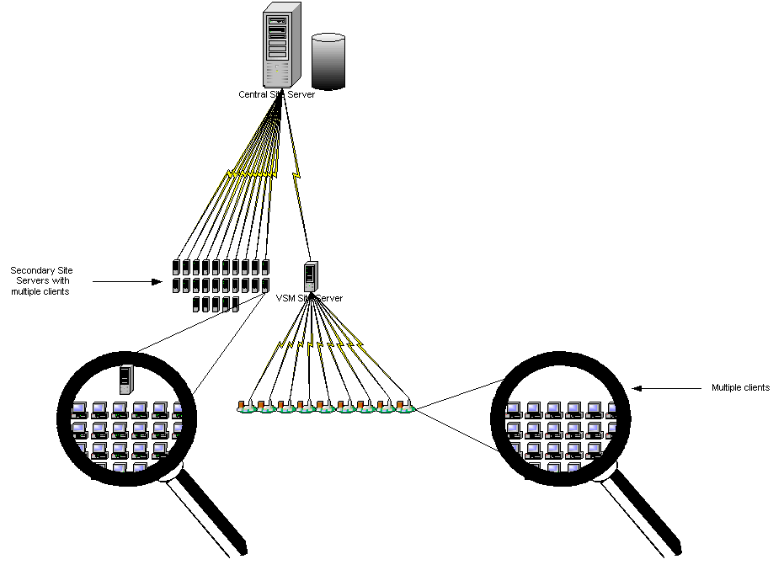

Diagram 7 – SMS Design with multiple Secondary Sites
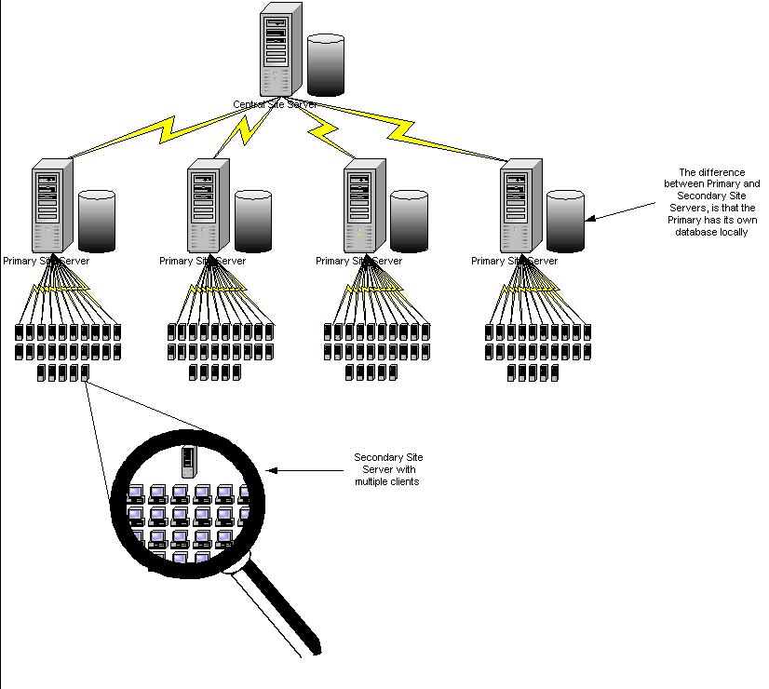

Known SMS Problems (Bugs) that are affecting SMS usage in the WAPS Network

- Client Appears as Not Installed in Administrator Console – TechNet article # Q241279 refers.
This has the effect of the Administrator not being able to target the SMS Clients for SMS Features, whereas they should be able to be targeted. The workaround for this problem does not correct the bug, and MS are investigating.
- SMS Executive Components Hang or Perform Slowly – TechNet article # Q237611 refers.
This has the effect of the site server in question not being able to process any SMS task. Performing the MS workaround can make the server unstable. This task is being performed on an opportunity permits basis.

SMS Changes

Due to the aforementioned problems, and in consultation with resources such as SMS Training documentation, SMS Resource Kit, MS TechNet, and MS consultation directly, a number of changes have been made to the original implementation.

These changes have had the effect of making more clients available, and the stability of the Central Site Server has improved.

Disabling of Windows NT Logon Discovery

Windows NT Logon Discovery is a method when each time a client logs on to the network, SMS will send information around the network to inform the site servers of the logon.

Details

The original documentation called for Windows NT Logon Discovery to be used to discover potential clients. Documentation provided from Microsoft has indicated that in a site such as ours, this should only be enabled on one site, and disabled on all other sites. If this is not the case, every time a computer logs onto the network, the computer sends a Data Discovery Record (DDR) to its site server. This DDR is then sent to EVERY site server.

To counter this, the proposed change has been made, and Network Discovery is now used to poll routers and clients periodically.

Effects

Reduced WAN and LAN utilization during most periods. Increased WAN and LAN utilization on defined subnets at defined times for defined periods.

Enabling of Network Discovery

Network Discovery will send requests to routers and network devices to determine their status as a potential SMS client.

Details

The full details as to how Network Discovery polls routers, extracts ARP tables, resolves MAC addresses to IP Addresses and Hostnames and then polls the device is out of the scope of this document. This discovery method is enabled on a per subnet basis, and is performed at set intervals/times and only for a certain periods. These periods are definable.

Effects

As detailed above in Disabling of Windows NT Logon Discovery

Disabling of Status Message Replication

Status messages show the current status of a site system.

Details

If configured, each SMS Secondary site will periodically send status information to its parent site. In the WAPS SMS Design there is only one parent site (the Primary/Central Site Server CBDXAEE), and so this site will receive across mostly WAN links, the status information from 81 Secondary Sites.

Effects

If disabled, CBDXAEE will not have to process the status messages, and will have more processor time to devote to other SMS tasks. If enabled, Microsoft states that CBDXAEE will eventually fail.
How SMS stands now

At this stage, SMS can be relied upon to give remote control access to some workstations at some sites.

This is dependant upon WAN utilization minute-to-minute at the sites in question. In short, we can expect that approximately 30 percent of the Metro workstations are available. This low number is expected to increase in the short term, and is a direct result of recent changes to the SMS installation (for example, the requirement to change SMS passwords).

Of the (approximate) 228 police locations in Western Australia, only (approximately) 75 of these have a ‘real’ server. By this, it is meant that there are only 75 servers that are currently capable of being an SMS site server. The remainder of the sites are only using NT Workstation and are not full servers.

The Road Ahead

Disclaimer: This section is an overview only, and does not contain the information necessary to make monetary decisions about a redesign of the SMS infrastructure.

Step 1. Remove all SMS components from the WAPS network.

Step 2. Proceed to rollout SMS in a structured manner, using one of the following as a goal:
- SMS working on only those sites that currently have a NT Domain Controller (no servers required), approx 20 sites)
- SMS working on all Metro sites (minimal servers required, approx 87 sites)
- SMS working on all non-metro sites (extra servers required, approx 141 sites)
- SMS working at all sites. (Large amount of servers required, approx 228 sites)

Note: It is currently not known what effects SMS will have on the smaller servers, with regard to disk space required and processor utilization. At a minimum, every server that becomes an SMS server is required to have NT Server installed. For the vast majority of sites, this will require a re-install of that server, a process that can only occur over a weekend, and charged to WAPS accordingly.

The SMS infrastructure review should be the subject of a separate project and funded accordingly.
Items that should be addressed include, but are not limited to;
- SMS Design review,
- Hardware requirements,
- Software requirements,
- LAN/WAN bandwidth requirements,
- Timescales / Man-days required,
- Testing of proposed design at diverse sites covering variables such as number of clients, bandwidth etc.,
- Objectives of finished design.

Conclusion

The SMS design implemented by the WAPS is one that should not, and will not work efficiently, effectively, or reliably.

Multiple sources (MS, SMS Trainers, SMS Documentation) when approached to comment on the WAPS SMS Design have expressed nothing but disbelief in the Network design and infrastructure, and have commonly stated that we need to redesign and spend more money on either more hardware, faster links, or both.

To alleviate problems in the short term, a separate document should be presented, detailing the new SMS infrastructure required, providing the basic hardware to allow SMS to operate reliably, efficiently, and be the most cost effective, both for CSC and the Western Australia Police Service.
This document will cover all tasks from the decommissioning of the existing design, through to the deployment of the new. It will clearly state that that sites that have satellite links without a site server will not be catered for in the new design.

Points that need to be considered are:

- Provision of Domain Controllers and Exchange servers at additional sites to minimize network traffic.
- Feasibility of re-use of older network hardware for DC/SMS/Exchange use (initially only for testing)

In short, the efficient use of SMS requires bandwidth and hardware that the WAPS have not provided. Until this time, SMS cannot be used, and is fact compounding the WAN problems even more.

Summary of problems:

- Lack of Domain Controllers
- Slow/congested links
- Lack of NT Server computers
- Central site server overloaded
- Insufficient number of SMS servers
Attachments:

  - WA Police SMS Design dated 4 October 1999
  - Addendum to SMS Design (page 1 only) dated 4 October 1999

